Dcl commands

(write description about what are dcl commands and it’s uses.

Dcl commands can only be performed by super users.

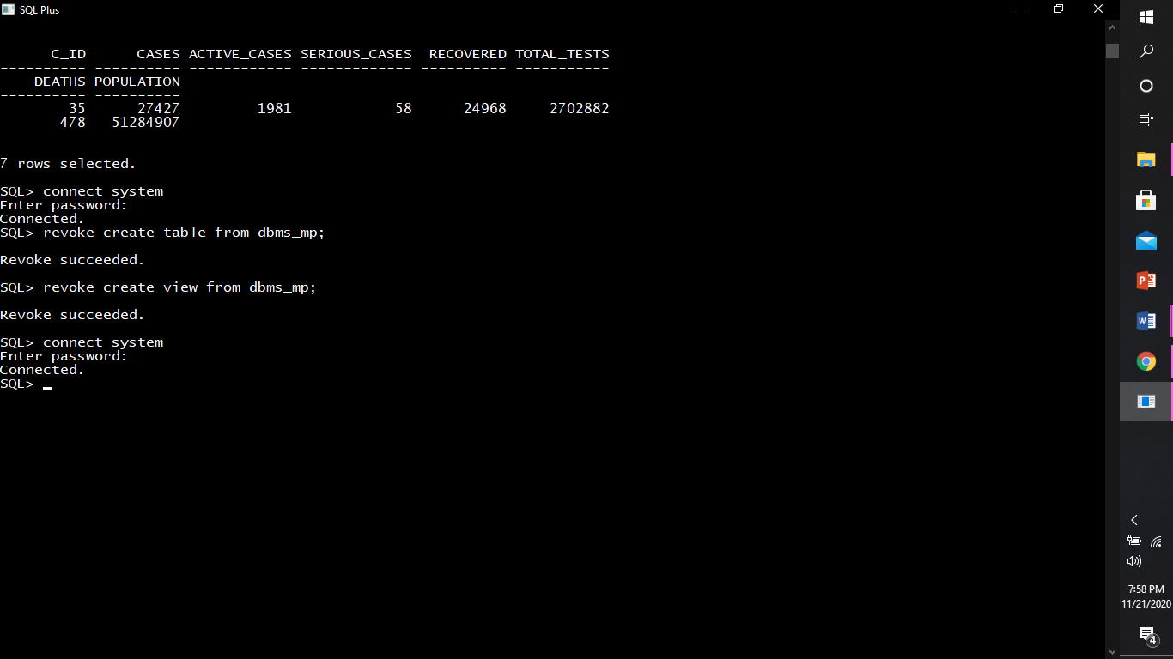

Grant command(description)

Ex:

We can grant all the privileges to user at once :

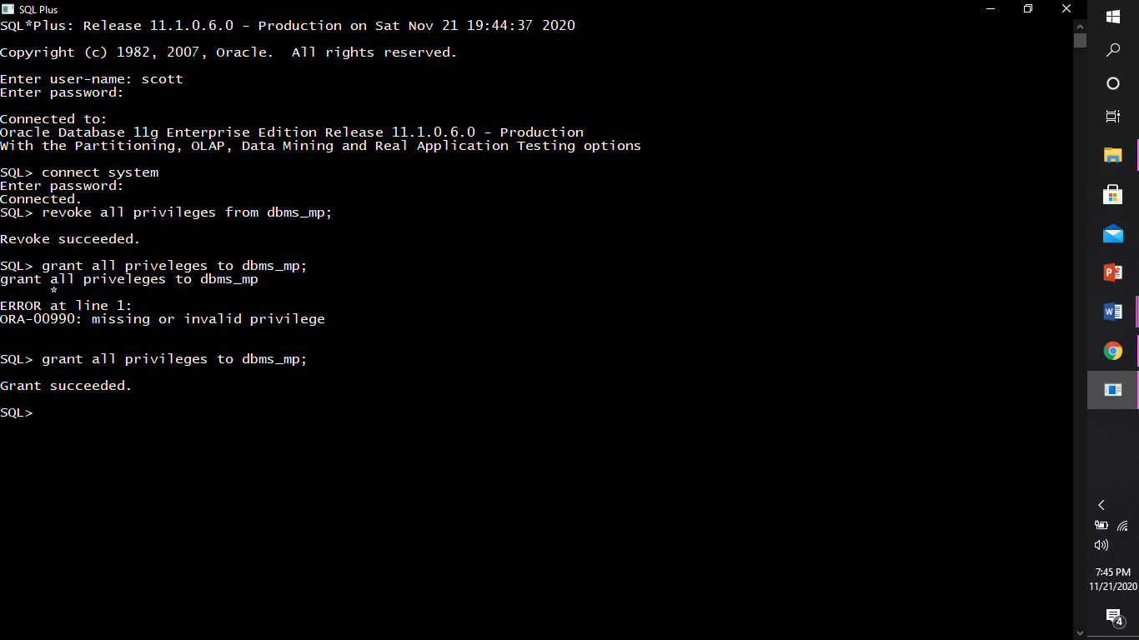

Or

Grant any specific privileges.

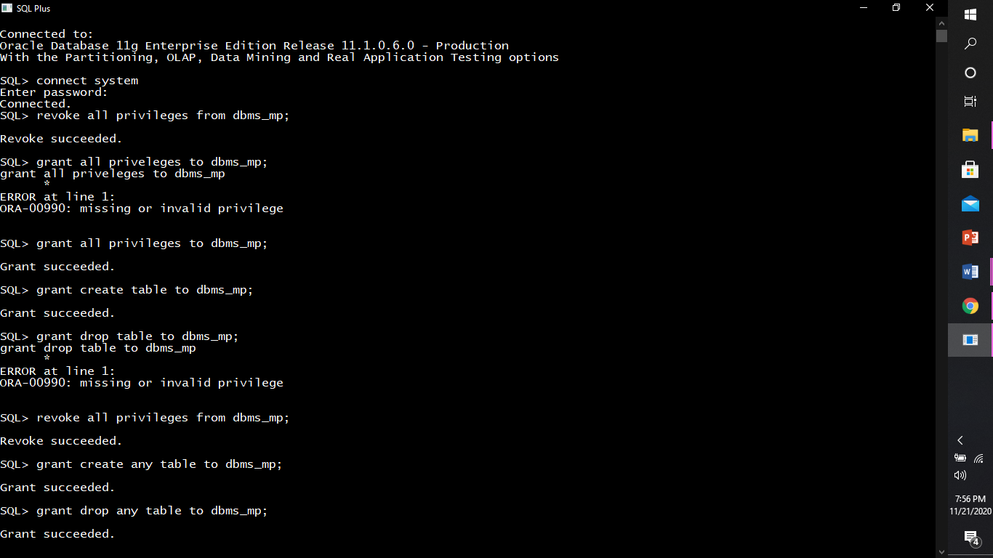

Revoke(descp)

Ex:

We can revoke all the privileges from user at once:

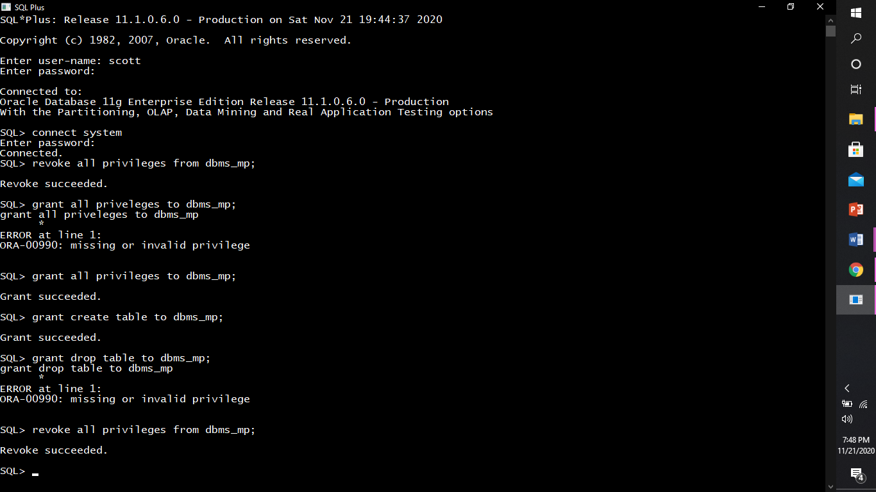

Or

Revoke any specific privelges.

